**Finding your Target Market**

**WTWA/KJ Waters Consultancy**

**June 11, 2019**

“Your target customers are those who are most likely to buy from you. Resist the temptation to be too general in the hopes of getting a larger slice of the market. That's like firing 10 bullets in random directions instead of aiming just one dead center of the mark--expensive and dangerous.” Entrepreneur Insider.

1. Find your Target Market – consider the following:

What authors inspired your book?

What popular authors have similar books?

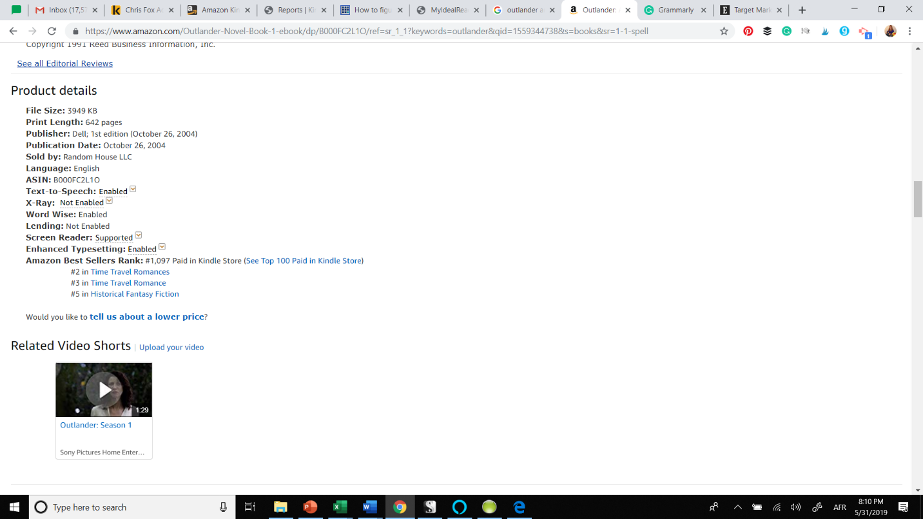What are other popular books in this genre?

*Tip: Find one of these books on Amazon and scroll down until you see product details, then click on top 100 paid in the Kindle store. (This is a great tool to use when creating your blurbs, categories, covers, etc.)*

*Tip: Do a quick search on Twitter using a hashtag from one of those books and see who is tweeting about it.*

2. Who are these readers? Jot down everything you can think of related to these readers.

Age:

Gender:

What entertainment do they consume?

What do they do for fun?

What other books and movies do they like?

What social media networks do they use?

Where do they buy their books?

3. How can you use this information to sell to your target market?

What social media sites are your readers using?

What other books/movies can you talk about to attract those readers?

Are they Amazon shoppers, or do the flock to specific sites to buy their books?